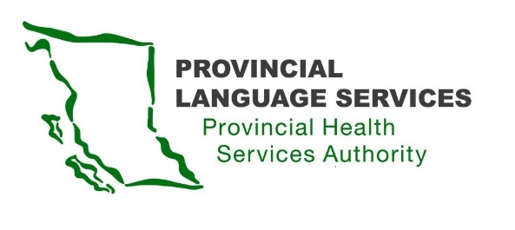

MINUTES | Community Advisory Group | Meeting #23

Date: January 25th

Time: 3:30 pm – 5:30 pm

Location: Virtual Zoom Meeting

Present: Brayden Walterhouse (Youth), Craig MacLean (Lower Mainland), Dan Braun (Lower Mainland), Jessica Niemela (Interior), Kirsten Ward (Northern), Leanor Vlug (Lower Mainland), Monika Lane (Vancouver Island), Vinu Abraham Chetipurackal (BIPOC), Scott Jeffery (Provincial Language Services), Kiran Malli (Provincial Language Services)

Facilitator: Christian Vasquez (Provincial Language Services)

Guests: Himani Bhatnager, Juliene Jagdeo (BC Centre for Disease Control)

Note-Takers: Rose Johnston, Alex Orivolo (Health information Management)

Regrets: Jennine Harris (Indigenous)

- Opening Remark

Welcome and Land Acknowledgement

This is the fifth meeting of a new three-year Community Advisory Group (CAG) term.

- Community Advisory Group (CAG) Meeting Dates

Provincial Language Services (PLS) will send quarterly meeting invitations for year of 2024 April, June, October, and January 2025. This schedule follows the fiscal year from April 1 to March 31 of the following year. Kindly respond to the invites so that PLS can track attendance.

- Review Action Items and Approve CAG Meeting Minutes

The members reviewed the CAG meeting #22 minutes. Leanor gave feedback about the minutes being hard to understand. Suggested using less technical language in the future for the clarity.

- BC Centre for Disease Control: Knowledge Translations Team
Presentation from Himani & Juliene:

Himani and Juliene from the BC Centre of Disease Control (BCCDC) Knowledge Translations Team were introduced and presented a presentation about what information the BCCDC provides, what kind this information is provided in, and what progress to make this information more accessible. They highlighted their team’s commitment to accessibility, including participation in an accessibility program and the new checklists for BCDDC and Health Authority employees.
Since the Web Content Accessibility Guidelines (WCAG) may not meet the experiences of those living in BC, Himani and Juliene wanted to gather feedback on how they can make the BCCDCs information more accessible from the committee member’s perspectives.
Feedback & Discussion:

Committee feedback and suggestions included:
- Translating documents into ASL for quicker access.
- Increasing font size further than 12pt,
- Concerns were raised about the limitations of using 811 documents for translations.
- The need for better broadcast of accessible options was emphasized.
- Suggestions included incorporating visual elements such as pictographs, QR codes, links, symbols, and visual stories for those with cognitive disabilities.
- Having in-person interpreters included in same screen broadcasts from the government.
- Offering opportunities to receive information in-person or having messages translated in braille for Deaf-Blind community.

Committee members actively expressed concerns about potential delays in translations, emphasize the valued importance of timely accessibility, particularly in emergency situations.
The possibility of engaging in advocacy efforts, including collaboration with organizations like the Canadian Deaf Grassroots Organization, was discussed to address the identified challenges.
Recommendations focus on language considerations, including making materials available in plain language, enhancing the website with visuals, and, hiring consultants with lived experiences, specifically Deaf and Deaf-Blind individuals.
Himani and Juliene appreciated the input that the community members had provided, and asked for advocacy groups suggested by committee members:
- Greater Vancouver Association of the Deaf
- Provincial Medical language Interpreting Service
- Deaf Well Being Program
- Okanagan Valley Association of the Deaf
- Family Network for Deaf Children
- Vancouver Community College
- Provincial Deaf and Hard of Hearing Services
- Deaf-Blind Planning Committee
- Northern BC Children and Families Hearing Society
- Canadian Deaf Grassroots Organization
- Wrap-up

Scott’s Updates:
Scott provided detailed updates on the continuing partnership with Provincial Virtual Health and emphasizing the commitment to improving access to virtual care with a specific focus on language accessibility. Also invited the committee members to join the Partnering on Appropriate Virtual Care group, as it will be helping build the foundation for supporting access to language and interpretive services.
Dan clarified the purpose of education for medical staff about accessibility barriers, while Brayden emphasize the importance of collaboration with PLS for simpler efforts.
Further Discussion:
Occurring concerns were raised about interpreter shortages, leading to a discussion on the establish interpreter training for better accessible healthcare services.
Leonor proposed a plan involving the screening for medical interpreter services to address not only the declining quality but also the shortage of interpreters.
Scott acknowledged the need for a screening process and emphasized in progress work on certificate to meet the quality of interpreting.
End & Next Meeting:
Christian wrapped up the meeting, inviting detailed feedback from the committee members. The next meeting, scheduled for April 6th, 2024 and members were encouraged to contribute their additional thoughts and concerns to PLS by email.

