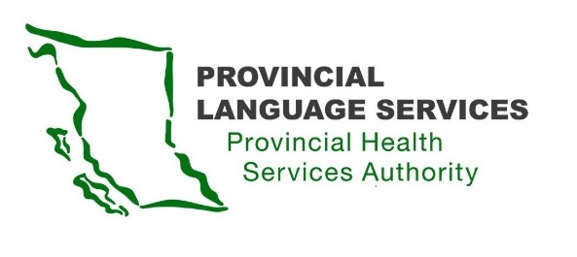

MINUTES | Community Advisory Group | Meeting #21

June 15, 2023

Meeting 3:30 pm – 5:30 pm

Location: Virtual Zoom Meeting

Present: Brayden Walterhouse (Youth), Craig MacLean (Lower Mainland), Dan Braun (Lower Mainland), Jessica Niemela (Interior), Kirsten Ward (Northern), Leanor Vlug (Lower Mainland), Monika Lane (Vancouver Island), Vinu Abraham Chetipurackal (BIPOC), Jenine Harris (Indigenous), Kiran Malli (Provincial Language Services), Scott Jeffery (Provincial Language Services)

Facilitator: Christian Vasquez (Provincial Language Services)

Note-Taker: Uzma Akbar (Provincial Language Services)

Guest Speakers: Tracy Conley and Michaela Watson

Regrets:

- Opening remark
Welcome and Land Acknowledgement
This is the third meeting of a new three-year Community Advisory Group (CAG) term.

- Community Advisory Group (CAG) Meeting Dates
Provincial Language Services (PLS) will send quarterly meeting invitations for April, June, October, and January. This schedule follows the fiscal year from April 1 to March 31 of the following year. Kindly respond to the invites so that PLS can track attendance.

- Review Action Items and Approve CAG Meeting Minutes
The members reviewed the CAG meeting #20 minutes.

- PLS Updates & Express of Interest for Patient Partners

Health Excellence Canada (HEC), a national organization, aims at improving virtual care. PHSA represents HEC in BC. PLS and Office of Virtual Health (OVH) are co-leading this group.

HEC is looking for patient partners from CAG representing the DDBHH to be a part of this group. Interested members must email PLS.

PLS Update: Silent Voice Resource Development Services (RDS) presented a curriculum for DDBHH which consists of 5 modules. Interviews were conducted with people who have lived experiences, and modules to be created once the editing is complete. These modules will eventually be uploaded on the Learning Hub available only in PHSA.

- Patient Safety Policy and Stop the Line Procedure

The purpose of this policy and procedure is to empower everyone at PHSA to feel safe to speak up for patients’ safety. Everyone at PHSA has a role in providing high quality safety to patients. This policy is looking at filling some gaps related to patient voice and how they can participate in the stop the line procedure.

  - Feedback on the suggested policy and procedure:
- Include some form of gesture to stop the line
- Have an in-person interpreter present at the medical facility, especially during a patient’s mental health crisis
- During a patient’s mental health crisis, the health care providers are responsible to step in and stop the line
- Sometimes interpreters may miscommunicate what the patient wants to relay. Provide a transcript of the conversation with the doctor as a back-up
- Educate health care providers on how to cater to DDBHH patients’ needs and ensure their ease of communication
- Sometimes incidents are not reported when they happen; it is important to circle back and discuss

  - How does the phrase “Speak Up for Patient Safety” resonate with you? Do you have any alternate suggestions?

- Use culturally appropriate phrase that works for all
- Use visual graphics
- Alternate suggestion: Pause! For Patient Safety

- Round Table:

  - Will there be a conflict of interest if a person is a CAG and HEC member?
Patient partners are individuals who have experience in the medical setting and want to share their lived experiences. No conflict of interest if an individual is a member of CAG and HEC.

  - Follow-up: Can interveners drive patients to and fro their medical appointments?
Update: The Risk Assessment team believes the interpreter/intervener takes on the liability when within the facility. It is considered an external risk if they take the responsibility outside the medical facility. No further updates on the matter and will follow up soon.

  - In the absence of VRI during an emergency situation, will the patient be prioritized if the interpreter is available?

PLS Response: Island Health recognizes the importance of interpreting services and are open to discussions and meetings with PLS. However, there is no mandate to prioritize DDBHH patients.

Action item: Look into the update of UPCC - Vancouver Island

  - The use of VRI in pharmacies -
Pharmacies located in hospitals use VRI but there are some pharmacies that fall out of the scope of PHSA. Research conducted by the Well Being program will be submitted to the College of Physicians and Pharmacists recommending that VRI should be provided to pharmacies.

  - CART services are used to schedule appointments but are they available for emergency services as well? Also, how can we increase the awareness of the existence of CART?
The uptake is gradually increasing and the stats are reviewed on a fiscal-year basis.
Currently there is no good solution for CART in emergency services although research is underway.
Communication team at PHSA is responsible for raising awareness and partners with the communication departments of external authorities.
CART services are provided in a remote fashion as of now.
  - Connect with Christian if there is no response from MIS while requesting an INT through text during an emergency. Two text numbers exist, one for day hours and the other for after hours emergency.
  - Currently, in-person interpreters on demand are not available 24*7, whereas VRI is on demand and available all the time.

- Wrap-up

Next CAG meeting to be held on Oct 12th, 2023.

