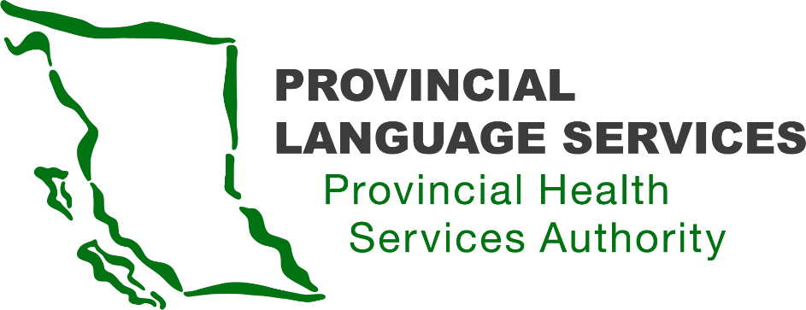
MINUTES | Community Advisory Group | Meeting 18

October 13, 2022

Meeting: 3:30 pm – 5:30 pm

Location: Virtual Zoom Meeting

Present: Craig MacLean (Lower Mainland), Dan Braun (Lower Mainland), Gordon Rattray (the Interior), Kiran Malli (Provincial Language Services), Leanor Vlug (Lower Mainland), Paula Wesley (Indigenous)

Facilitator: Scott Jeffery (Provincial Language Services)

Note-Taker: Judy Hsiao (Provincial Language Services)

Regrets: Sarah Taylor (Lower Mainland), Monika Lane (Vancouver Island)

Review Action Items and Approve Community Advisory Group Meeting Minutes
- Community Advisory Group meeting #17 minutes approved.
- If there are grammatical errors, email Judy to make corrections.

- CAG Membership
- It has been 3 years since CAG was initially formed. As this is the end of the first three-year term, members must decide to continue serving as a CAG member for a second term or step down.
- Members who decided to step down:
  - Gordon Rattray (the Interior)
  - Sarah Taylor (Lower Mainland)
  - Paula Wesley (Indigenous)
- PLS expressed appreciation towards all CAG members, especially thanked Gordon, Sarah, and Paula for their dedication and commitment to making the healthcare system more accessible.
- The recruitment of new CAG members will start in November. Scott will work on a recruitment Vlog looking for individuals from diverse groups.

- Fiscal Year 22/23 Goals and Objectives Report
Roadmap updates -
- Updated locations of Video Remote Interpreting (VRI) in Emergency Department (ED) as of October 2022:
  - On Vancouver Island, VRI is available in Victoria General Hospital and Royal Jubilee Hospital. The one in Comox Valley Hospital is coming soon.
  - In Northern BC, VRI is available in Quesnel, Valemount, McBride, University Hospital of Northern British Columbia (UHNBC), Vanderhoof, St. John Hospital, and Fort St. James Hospital
  - Island Health is adding more VRI in the ED across the island.

- Expanding VVI and VRI services
  - Reviewed Doctors of BC (DoBC) Electronic Medical Records (EMR) video platforms with more than two parties.
  - DoBC/ Doctor of Technology Office (DTO) – Physician Engagements on November 30

- Updates
- PLS Website
  - PLS has been working on updating the PLS website to clearly explain what service is covered; also merging sign language with spoken language as in one interpreting service.
  - Also, there are short URLs to specific pages, including DDBHH and Legal Rights.
    - PLS: www.phsa.ca/pls
    - DDBHH: www.phsa.ca/ddbhh
    - Legal Rights: http://www.phsa.ca/ddbhhlegalrights

Action Item: Scott is to re-check the link and send in an email – Completed as of October 14.

- DDBHH - Customer Service Representative (CSR)
  - PLS is excited to expand the team by recruiting a CSR from the DDBHH community.
  - This role will mainly handle ASL requests, improve communication between Wavefront and PLS, and bring cultural awareness.
  - An ASL Vlog posting is on Facebook. The position is still open, so feel free to share.

- BCEHS VRI Focus Group
  - For the past year, paramedics in BC have had access to the ASL interpreter (INT) through VRI. PHSA would like to hear from the DDBHH community who had used this service with paramedics to evaluate and identify areas of improvement.
  - The Focus Group will be held on Zoom: on November 3, 6:00-8:00 pm
  - Open for registration. An ASL Vlog has been posted on Facebook as well. Feel free to share with those who had experience using VRI with paramedics.

- ASL Translation Service
  - PLS signed a contract with the CONVO Canada Translation team to expand our translation service for better quality and speed of service.

- Interpreter Engagement Session
  - PLS will hold an interpreter engagement session about Medical Interpreter Screening.
  - The purpose of this engagement will help build a relationship with INT and collect their thoughts on medical interpreter screening.
  - Planned for later this fall

- Association of Medical Professionals with Hearing Losses (AMPHL)
  - Scott briefly shared his experience attending the AMPHL conference and co-presenting with Felicia D’Amato.
  - Great networking opportunity with DDBHH medical professionals and administrations in North America.

- Round Table and Q & A
- Question:
With VRI in many Emergency Departments, has there been training for ED staff on how to use it? There is a high turnover rate in EDs. Is there a succession training plan in place, so everyone knows how to use it?

Answer:
When we roll out VRI in a new facility, PLS Language Service Coordinator provides training to a designated contact person. That person will then be in charge of training the rest of the staff, including new hires. PLS shares any service updates whenever possible.

Please note that Fraser Health (FH) and Vancouver Coastal Health (VCH) manage their own VRI now.
Anosha does connect with FH and VCH regularly, and if there is any issue/concern, PLS works together with FH to resolve. PLS provides VRI training to the rest of BC.
- Comment:
Members feel that there is not always enough time for in-depth discussion during CAG meeting, use the opportunity for more inputs from the members.

Response:
Scott will look into re-organizing meeting agenda to allow more time for Round Table discussion.

- Comment:
One member shared his poor experience with VRI at ED. The VRI on a mobile pole was not movable, making it difficult for both patient and INT to see each other clearly.

Response:
PLS will look into options on how to position VRI devices with some flexibility to move and adjust to different angles.

- Comment:
In reviewing the Terms of Reference (ToR), members feel that the role of CAG is being underutilized. They hope for more opportunity to get involved, to provide advices, and to be bridge to the community. Members recognized PLS’s effort and improvement in creating more accessibility; meanwhile, more engagement from more representatives from the community is important.

Response:
PLS appreciates all the valuable feedback from the members. These are all important points and PLS could not have done any achievement without the insights and guidance from CAG members. The ToR sets the expectations of the roles of CAG members, but can be modified if needed.

- Comment:
Members expressed concern over the Patient Care Quality Office and the complaining process. Many have experienced frustration with the complaining channel. The system is inaccessible, not responsive, and not cultural sensitive from the perspective of the DDBHH community. Ombudsman may be an option.

Response:
PCQO has long been having capacity issue and they can do better with accessibility on their website. On the other hand, PLS Training and Interpreter Resource Coordinator who is monitoring PLS Quality Assurance had meetings with PCQO. They ensure that if a complain involves a DDBHH individual, they will connect with an interpreter.
- Question:
Scott shared graph of ASL INT requests analysis including outcomes such as filled and unmet in previous meeting. Is there also statistics concerning Deaf-Blind including Deaf Interpreter (DI) requests, DI filled, Intervenor requests etc. for medical appointments?
Answer:
PLS has statistics on numbers of DI been requested as well as of filled and unmet. There has been no intervenor requests yet, though. PLS has started to collect a person’s identity (Deaf, Deaf-Blind, and Hard of Hearing) from Wavefront, in order to improve the statistics on the numbers of DDBHH in each health authorities region.
Action Item: Scott to connect with Craig to discuss how to spread the word to the Deaf-Blind community about intervenor in health care.

- Wrap-up
PLS is still working on increasing accessibility to its website. There will be ASL translation embedded throughout, as well as French translation on each page. May expand to other major languages in the future.

New CAG member recruitment Vlog will be shared as soon as it is ready. Stay tuned!

Meeting adjourned at 5:30 pm

