
Bedside Quick Guide: Proning with Ceiling Lift (OHL)

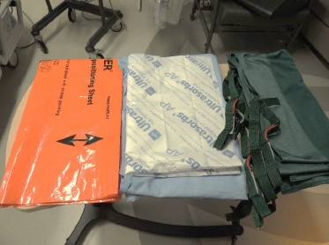
Equipment required
- Ceiling lift with positioning sling
- Foam head positioner
- Bed linens and absorbent pads
- Pillows/positioning wedges (chest, hips, legs)
- Emergency airway and reintubation equipment
- Cardiac monitor and defibrillation pads
- ACLS emergency drugs and equipment

Patient Preparation
- Confirm readiness: Verify sedation/analgesia plan, intubation-skilled physician availability, and equipment readiness.
- Patient prep: Perform oral/eye/skin care, remove gown as appropriate, assess skin/pressure points, and apply protective dressings.
- Lines & tubes: Secure airway, lines, drains, and catheters; disconnect non-essential equipment; direct lines above the waist toward the head and lines at/below the waist toward the feet; confirm and document tube insertion lengths.
- Positioning & monitoring: Reposition ECG leads if needed and ensure all lines and cables have adequate slack.
- Nutrition: Assess tolerance and aspiration risk; continue feeds if stable or pause if unstable.

2. Pre-brief
- Team & leadership: Confirm team members, roles, and designate an experienced team leader.
- Airway & physician support: Review airway plan, identify airway lead, and confirm physician skilled in airway management is present or immediately available.
- Indication & risks: Confirm indication and anticipated duration of proning; review key risks and mitigation strategies.
- Sedation & readiness: Ensure adequate sedation/analgesia (consider NMB as appropriate) and confirm all required equipment is available and functioning.
- Communication & contingency: Review sequence, safety checks, communication plan, and emergency return-to-supine plan.
Emergency Event | Potential Cause | Immediate Action / Mitigation Strategy
Airway dislodgement or obstruction | Excessive tube tension, poor stabilization, or patient movement during turn | • Immediately stop the turn.  • Airway Manager to stabilize and confirm endotracheal tube (ETT) placement.  • Reassess ventilator connection and oxygenation before resuming.
Hemodynamic instability | Altered venous return or compression during turn | • Pause procedure.  • Return to supine if instability persists.  • Reassess fluid status, vasoactive infusions, and positioning.
Accidental line or catheter dislodgement | Inadequate line orientation or tension during movement | • Halt procedure and apply direct pressure if required.  • Re-establish access as needed.  • Confirm securement and orientation before continuing.
Desaturation or ventilator disconnect | Airway kink, ventilator circuit tension, or loss of seal | • Reconnect circuit and ensure tubing slack.  • Check ETT patency, cuff pressure, and ventilator function.  • Resume proning once oxygenation stabilizes.
Pressure or skin injury | Prolonged pressure on bony areas or devices | • Reposition supports and inspect pressure areas post-turn.  • Apply protective dressings and maintain reverse Trendelenburg.

3. Positioning Slings and Supports
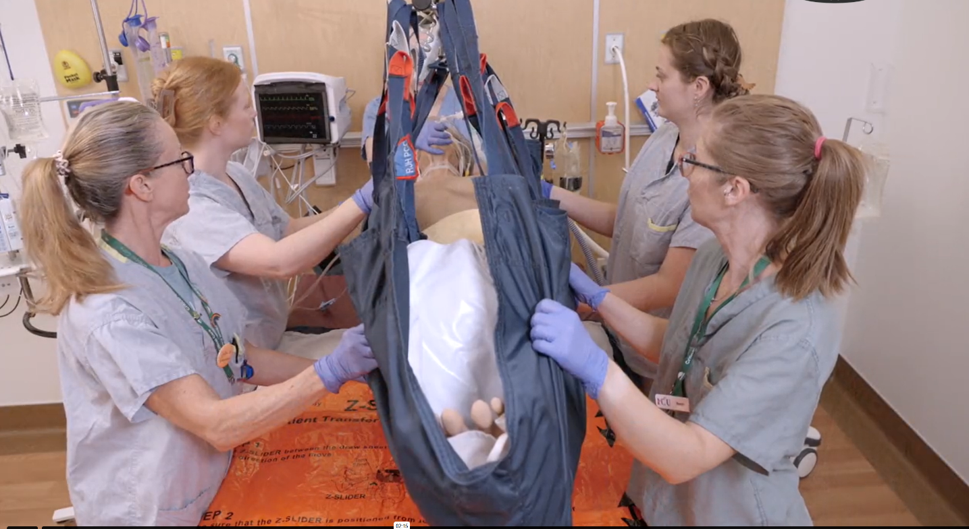
- Center patient: Ensure patient is centered on the sling to
maintain even weight distribution and prevent rotation.
- Lift and balance: Slightly lift using the overhead lift and adjust
sling loops to achieve balanced elevation.
- Layer linens (bottom → top): Positioning sling → clean sheet
→ absorbent pad → transfer sheet to create a clean, low friction turning surface.
- Align sling: Position the top of the sling at the shoulders or
base of the neck to support head, neck, and upper-body alignment.


4.Turning patient prone
Bedside Quick Guide: Proning with Ceiling Lift (OHL)
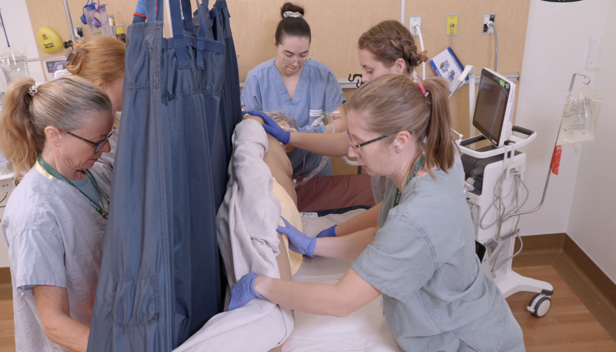
    - Position for turn: Move patient laterally toward the bed
edge away from the ventilator to create turning space.
    - Create slack: Lower patient slightly and remove sling
loops on the ventilator side.
    - Prep limbs & linens: Tuck linens/transfer sheet and position
patient’s hand under hip for the turn.
    - Controlled rotation: Raise with overhead lift; staff guide at
shoulders and hips without pushing to initiate the turn.
    - Safety pause: Stop in side-lying to reassess airway/ETT and
verify line and drain security.
    - Complete prone: Continue controlled roll to prone with
head toward the ventilator for airway visibility and circuit stability.

Positioning supports
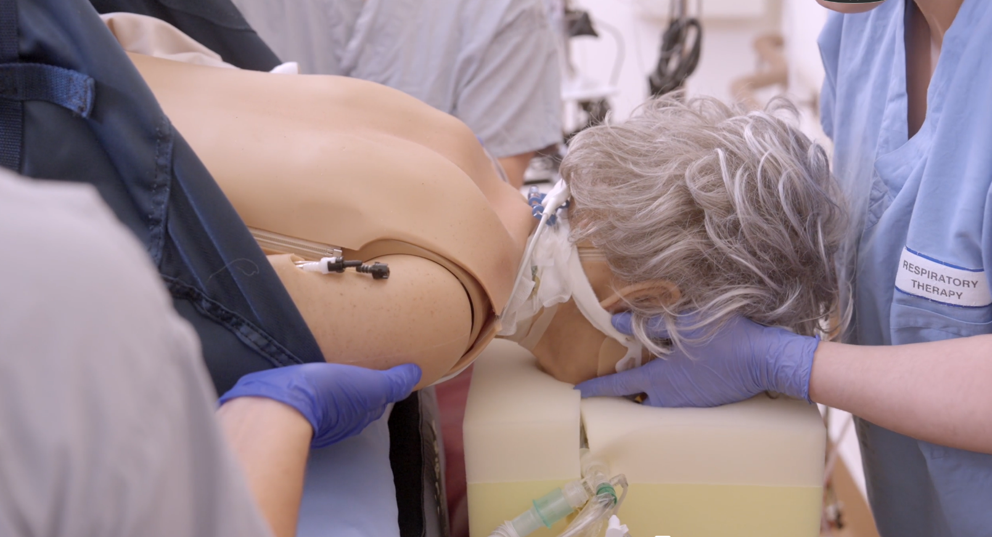
    - Reattach sling loops: Use loops needed for balanced lift;
do not use top head loops once prone. Adjust loop combination
as needed for patient size and stability.
    - Lift to place supports: Raise patient with overhead lift to
create space for supports while maintaining airway and line stability.
    - Head & airway support: Place foam head positioner with ETT centered;
airway lead guides tube as patient is lowered.
Ensure ears, eyes, nose, and lips are pressure-free.
    - Trunk & lower body support: Place pillows/wedges under
chest/shoulders (below clavicles), hips, and lower legs to maintain
alignment and offload pressure.
    - Arm positioning: Position one arm in swimmer’s position; place the
opposite arm alongside the body with elbow slightly flexed and palm up or inward.

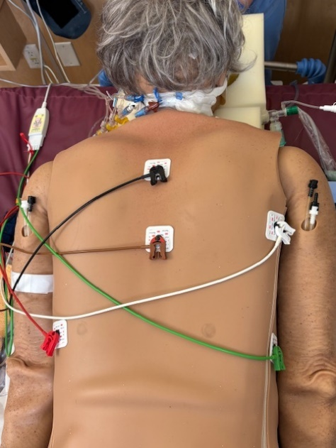
Position Optimization & Final Checks
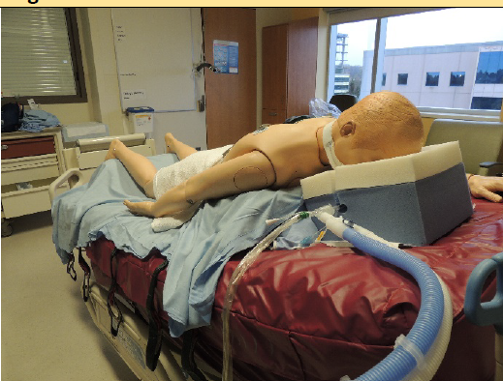
- Airway secure: ETT position confirmed, cuff intact, ventilator settings
and circuit verified
- Face protected: Ears flat, eyes closed without pressure, lips free,
head aligned toward ventilator
- Lines & drains safe: All lines, drains, Foley patent, correctly oriented,
and tension-free
- Monitoring active: ECG, SpO₂, BP reconnected with reliable waveforms
- Position optimized: Neutral alignment, pressure points offloaded,
bed in reverse Trendelenburg (15–30°)
- Patient tolerated: Respiratory and hemodynamic stability confirmed;
feeds resumed if appropriate
- Documented: Time proned, staff present, airway confirmation,
supports used, and any issues
- 1 L normal saline labeled “For CPR” present at bedside (included in daily nursing safety checks for proned patients)

