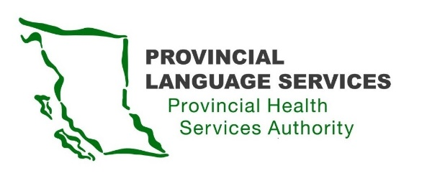

MINUTES | Community Advisory Group | Meeting 4

20 March 2020

Meeting 10 am – 1 pm
Location: Online, IMITS Meeting Platform
Present: Monika Lane (Vancouver Island), Nancy Zavaglia (the North), Leanor Vlug (Lower Mainland), Dan Braun (Lower Mainland), Craig MacLean (Lower Mainland), Gordon Rattray (the Interior), Kiran Malli (Provincial Language Services)
Facilitator: Dr. Joe McLaughlin
Note Taker: Emina Dervisevic (Delaney + Associates)
Guests: Provincial Health Services Authority Communications – Jose Vargas and Gary Carr

Welcome Meeting Facilitator
Kiran: Welcome to Dr. Joe McLaughlin.

- Due to the crisis with Covid-19, it is a new situation; the meeting has been moved online, and Kiran will be able to stay with us until 11 am.

Communications Plan
Presentation of the Draft Communications Plan by Jose Vargas

  - What type of Sign language should be used in Provincial Health Services Authority communications?

- American Sign Language (ASL); there are also the Langue des signes Québécoise (LSQ) and Indigenous Sign Languages used across Canada, but in British Columbia, people are generally using American Sign Language.
- It is also important to involve Deaf Interpreters and native Signers; there needs to be a diversity of interpreters.
- Vlogs are hard to see for Deaf-Blind people; information presented must be provided in written transcript or alt-text.
- The use of intervenors for the Deaf-Blind should be an option. British Columbia does not have the same recognition of intervenor services as some other provinces. There should be training for intervenors in British Columbia and funding to provide services for Deaf-Blind youth, adults and seniors.

  - Social Media

- The community is comfortable using social media, but some Deaf and Deaf-Blind persons choose not to use social media, so other ways of communicating should be used as well (email or Canada Post).
- Provincial Health Services Authority needs to have the authentic voice and be the source of truth.
- Discussion about allowing comments on social media: some think comments should not be allowed; some think comments should be allowed but moderated by Provincial Health Services Authority.
- There is also a plan to have a communications calendar with messages that will vary in tone and information. All suggestions will be taken into consideration when Communications are building the social media channels.

All the input is greatly appreciated and will be considered by the Communications (Jose and Gary).

  - Newsletter / Email / American Sign Languages Vlog

- One thing proposed is a subscription-based newsletter – quarterly or twice a year, to develop and hold an audience, to develop content, and to share information about the program and provide general updates.
- Email list is great, but some of the senior community members might not use social media or be able to access online newsletters; it would be good to also print newsletters.
  - Email subscription needs to be safe and confidential (undisclosed list); and it can be like the email lists that DeafBC.ca and Canada Video Relay Services already have. Also, Community Advisory Group members’ emails should not be shared with anyone.
- Twice a year would not be enough, quarterly newsletter is better.
  - People who do not use Facebook should receive email updates. (Some Community Advisory Group members prefer quarterly Newsletter updates, and some would like to receive emails when posts are made on Facebook, so that the email calendar matches the social media calendar).
- Materials should also be translated into Braille.
- Sending out documents in pdf is safer, but for the Deaf-Blind, documents should be sent in Word.
- Agreed by everyone that videos in American Sign Language need to be continued.

  - Communications Tactics

Presentation of planned tactics in the Communications Tactics by Gary Carr.

- The goal is to increase awareness of the program; some of the opportunities are local and international events (DeafBlind Awareness Month, Int’l Week of the Deaf, Canada Deaf Expo (cancelled due to Covid-19)); the idea is to ask about other events that Communications may or may not know about and integrate them into the plan.
- Communications will be reaching out to the Community Advisory Group for story ideas – profiling the Provincial Language Services staff, examples of when people had a good experience with Provincial Language Services, etc.
- Information will be added to the Provincial Language Services webpage so that people can access accurate source of news.
- Discussion about the opportunity for the Provincial Health Services Authority website to be a source of information in American Sign Language about Covid-19 and related information: the community is seeing a lot more interpreters on TV, which is a huge improvement - additional areas of improvement would be to be able to use Video Relay Service to call 811 and for Provincial Language Services to continue to be a source of good information (public health news or anything health-related; there could be links to Global News on the Provincial Language Services page, for instance).

Action Item: The Communications team will consider all the input and reach out to Community Advisory Group with questions about the proposed Communications Plan and tactics.

Recruitment of New Members
- Two members of the Community Advisory Group have resigned – Sarah Taylor temporarily (the Community Advisory Group approved this), and Paula Wesley due to health reasons.
- Members are encouraged to reach out to their communities and seek community members that would be able to bring Indigenous perspective to the Community Advisory Group.

Finalize Input on Request for Proposal Contents
- Discussion about the final questions regarding the Request for Proposal content.

Meeting adjourned at 12-noon due to a poor WiFi connection.

