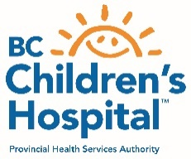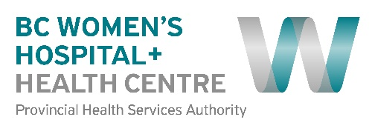  University of British Columbia – Children’s & Women’s Research Ethics Board | UBC C&W Research Ethics Board  Room A2-141A  950 West 28th Avenue  Vancouver, B.C. V5Z 4H4  Tel: (604) 875-3103  Email: cwreb@bcchr.ubc.ca  Website: www.phsa.ca/researchethics  RISe: https://rise.ubc.ca

C&W Research GUIDANCE - RESUMPTION OF RESEARCH

- Currently approved research projects
  - Projects that have been halted due to COVID-19
    - If your research was halted due to the curtailment but you did not notify the REB and you feel that you research meets the criteria for stage 1 (critical, on-site research), fill out the intake form. If approved you do NOT need to notify the REB
    - If your research was halted due to the curtailment but you do not meet the criteria for resumption (not critical and cannot be conducted without in-person interactions), continue to POSTPONE your research until you qualify for resumption of your research.
  - Projects that were modified due to COVID-19
    - If you modified your research to continue without in-person activities TEMPORARILY and wish to come back on site, fill out the intake form and once approved, notify the REB that your research is back on-site and will be conducted as originally approved. Otherwise, any changes resulting from the resumption of research will need to be outlined via an amendment in RISe (ie. Changes to recruitment, consenting etc)
    - If you modified your research PERMANENTLY to remove in-person activities then no action needs to be taken.
  - Projects that were not affected by COVID-19
    - Projects that have never involved in-person research activities (and do not require on-site resources or require staff to be on-site) can CONTINUE as approved.
  - Projects that have received a CONDITIONAL APPROVAL from the REB
    - If your project meets the criteria for resumption, complete the intake form and when approved, notify the REB so we can release the final approval certificate in RISe.
    - If your project does not meet the criteria for resumption continue to wait for the next steps
  - Projects that have received a FULL APPROVAL from the REB with exemption
    - Projects that are up and running via exemption will need to complete the intake form to remain on site but the REB does NOT need to be notified.

- New research projects that will be reviewed and approved by the REB
  - COVID related projects that have received an approval via the intake form
  - Critical in-person research projects that have received an approval via the intake form
  - Research projects that do not involve in-person interactions and can be conducted remotely
All other research submitted will be reviewed but will receive a conditional approval from the REB. Once the curtailment has been lifted, these projects will receive a full approval to begin.

