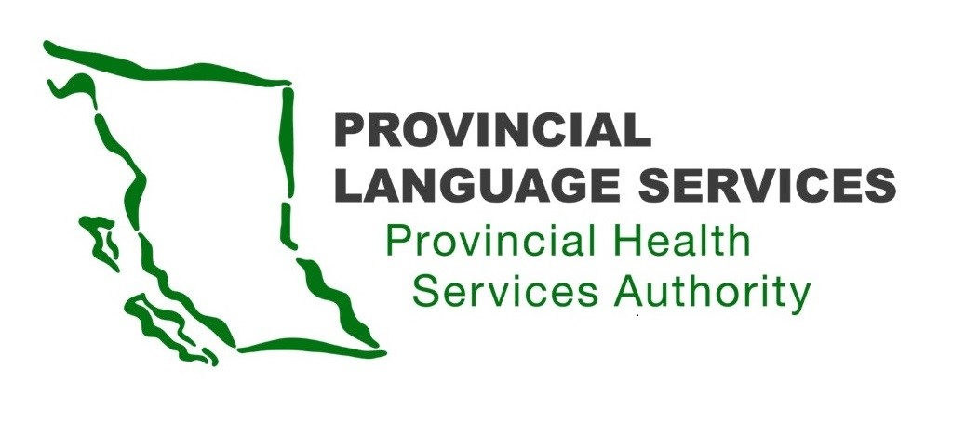

MINUTES | Community Advisory Group | Meeting 15

January 13, 2022

Meeting 3:30 pm – 5:30 pm

Location: Virtual, Zoom Meeting

Present: Craig MacLean (Lower Mainland), Dan Braun (Lower Mainland), Gordon Rattray (the Interior), Leanor Vlug (Lower Mainland), Monika Lane (Vancouver Island), Kiran Malli (Provincial Language Services), Paula Wesley (Indigenous).

Facilitator: Scott Jeffery (Provincial Language Services)

Note-Taker: Chelsea Numanga (Provincial Language Services)

Absent: Sarah Taylor (Lower Mainland)

Review Action Items and Approve Community Advisory Group Meeting Minutes
- Abbreviations and acronyms from all previous Community Advisory Group meeting minutes should be replaced with the complete spelling of each word so that the public can better understand all terms used.

Action Item: Chelsea to expand all acronyms and abbreviations from all previous Community Advisory Group meeting minutes with the complete spelling of each word.

Strategic goals for FY21/22

Goal 1: Develop specific cultural competency training for Healthcare Providers relating to Deaf, Deaf-Blind and Hard of Hearing (DDBHH) patients.

Goal 1 Objectives
- Implement an online training module for DDBHH cultural competency.
- Strategies for effective communication.
- How/when to request communication to access services, including:
  - Sign Language Interpreters;
  - Deaf Interpreters;
  - Intervenors;
  - Communication Access Real-time Translation (CART); and
  - Video Remote Interpreting (VRI).
- Competency training for new employee orientation in PHSA.
  - We would first set this training up for Provincial Health Services Authority (PHSA) staff to create a model for this objective. Once we have a model, we will be able to roll it out to the rest of the province.
  - Office staff, Medical Office Assistants (MOAs), and frontline staff would all be included.
  - This training is for new hires and is separate from the incident response.

Goal 2: Expand Virtual Interpreting services in BC: Virtual Visit Interpreting (VVI) and Video Remote Interpreter (VRI).

Goal 2 Objectives
- Implementation of VRI in all Emergency Departments in B.C.
  - We have begun rolling this out.
- Expand VVI or VRI services in:
  - Clinics with DDBHH patients.
  - High-demand clinics (e.g. surgery).
  - Clinics where no interpreters are available (e.g. rural locations). We want VVI or VRI available as a backup if we cannot get an interpreter there.

Goal 3: Develop and carry out key community engagement strategies

Goal 3 Objectives
- Consult with DDBHH Community and Stakeholders and provide information to them.
- Provincial or Regional Outreach
  - Networking
  - Presentations
  - We want to make sure everyone understands what Medical Interpretation Services look like and that we are being transparent
- Advance PMSLIS VLOGs
- PMSLIS = Provincial Medical Sign Language Interpreting Service
- Create an Informed dialogue (updates or review).
- Sharing Information (new services or change services) regularly. This includes reposting relevant information from the past that is still relevant now.

Question: Could we make vlogs with instructions on how to get an interpreter?

- Update on PMSLIS lack of interpreters
- We understand there is a lack of interpreters from Wavefront, and Provincial Language Service (Provincial Language Services) has worked with Wavefront to resolve this.
- Wavefront is starting to sign contracts with new interpreters, so a more significant number of interpreters are available for booking going forward.

- Update on Video Remote Interpreting (VRI)
- Interior Health now have two VRI installed in Kelowna General Hospital and Penticton Regional Hospital Emergency Departments.
- Northern Health and Island Health will most likely start later this year.
- BC Emergency Health Service (BCEHS) and Provincial Language Services are working together to develop an education package for their new employee orientation.
  - This would help their students and new hires learn new terminology and provide video training to recognize VRI and where to find it. E.g. if a Deaf person writes VRI or INT on a piece of paper, then the paramedics and dispatch will be trained to respond.

- Update on Communication Access Realtime Translation (CART)
- We have chosen a vendor to provide CART services, and we have already done a soft rollout with a few Hard of Hearing patients.
- We are currently using Zoom caption until we get a Private Impact Assessment for StreamText. With the Assessment, we will not have to use Zoom if patients visit Healthcare Providers in person.
- We are working on a communication rollout. According to the Canadian Hard of Hearing Association of B.C., no CART services are offered in North America, so Provincial Language Services may be the first to provide this type of service.
- We are still working on the Policy and Guidelines. Since this is new to Healthcare, we must develop guidelines on using the CART service, both in-person and remotely.

- Update on Doctors of B.C. (DoBC) and the Divisions of Family Practice
- Provincial Language Services is working closely with DoBC and the Doctor Technology Office (DTO) to ensure that the General Practitioner and Specialist doctor's offices are educated and aware of their responsibility for booking ASL interpreters.
- DoBC and the Divisions are changing their websites and improving their information about how to work with interpreters, requesting an interpreter etc.
- We have encouraged DoBC and the Divisions to make sure they are encouraging Healthcare Professionals to use Zoom rather than platforms like Doxy.me or MyStreams that are not as good.
- We hope to create a patient information sheet for Deaf patients to show Healthcare Providers this information.
- We are developing an education package for Medical Office Assistants to be familiar with Provincial Language Services.
- DDBHH individuals must make sure that their video mail or sign mail is working.

- Update on Medical Interpreter Screening
- Provincial Language Services is working with a potential vendor and reviewing their procedure.
- We do not plan to implement this until the fall of 2022.
- Doctors Technology Office has a virtual support desk that offers technical support to Healthcare Professionals and Interpreters.

- Update on Patient Care Quality Office (PCQO)
- Provincial Language Services is working with the PHSA PCQO to make their offices accessible, allowing DDBHH to make compliments or complaints in their native language. We are working on other Health Authority PCQO offices as well.
- We are redirecting any Patients' or loved ones' complaints or compliments to PHSA PCQO, as they will get an official record and do a proper procedure to investigate.
- DDBHH Patients should make complaints through PHSA PCQO, not through Wavefront.
- We have made this information clear on our website, and we will create more vlogs to supplement this.

- Update on COVID-19 and B.C. Centre for Disease Control (BCCDC)

- Provincial Language Services has received requests from the DDBHH community for information in ASL about COVID-19 and the Omicron variant, including why the cases are so high compared to last year.
- We arranged an Update and Q&A on COVID-19 with Dr. Lavoie - Deputy Provincial Health Officer. This event occurred on the evening of this Community Advisory Group meeting, January 13, 2022. Two ASL interpreters and a CART captioner helped with this event, and a record of it has been posted online:
https://www.youtube.com/playlist?list=PLWC86RnHk60DYDX02L_v4tYlgMe-bKzMB

- In addition, we are working closely with BCCDC to ensure that information about COVID-19 is being translated into ASL more frequently.
- We recorded the questions asked in this event and then would bring them over to BCCDC to see what topics the community has lacked from ASL translation.
- We discussed an illustration with information in plain English, made by an Indigenous Group; see link: http://www.bccdc.ca/Health-Info-Site/Documents/COVID-19_vaccine/Max_vaccination_protecting_communities.pdf
    - It may not be visually appealing for people with low vision. Information in ASL may be better for the general public.
    - These images could be good to supplement information posted in ASL.
    - This may be a good resource for parents with DDBHH children.
    - These images may clash with Deaf culture, e.g. the person is picking up the phone, which could imply that DDBHH individuals may need to depend on hearing family members. However, you cannot text to book an ASL appointment with your Healthcare Provider, which may be the message here.
    - Simpler, static images may be helpful, for example, a picture of getting the vaccination and having a sore arm, with the English word 'vaccination' written alongside it, to bring literacy exposure to the DDBHH community.
- BCCDC is starting to work on surveying DDBHH to collect more information about what they should focus on.

Decision: Illustrations specifically made for DDBHH, and posted on the PMSLIS webpage, would be beneficial.

Meeting adjourned at 5:32 pm.

