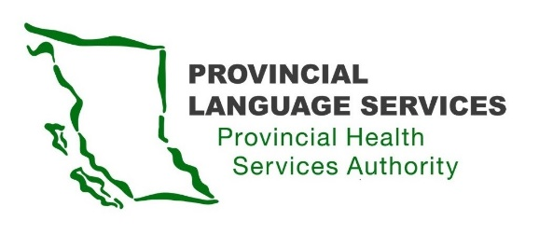

MINUTES | Community Advisory Group | Meeting 1
22 November 2020

Meeting 10 am – 1 pm
Location: Willingdon Office

Present: Monika Lane (Vancouver Island), Nancy Zavaglia (Prince George), Leanor Vlug (Lower Mainland), Dan Braun (Lower Mainland), Craig MacLean (Lower Mainland), Gordon Rattray (Kelowna), Kiran Malli (Provincial Language Services), Angela Chirinian (Provincial Language Services)
Regrets: Sarah Taylor (Lower Mainland)
Facilitator: Emina Dervisevic, Delaney +Associates
Note Taker: Brittany Mason – Delaney +Associates

- Welcome
Welcome from Kiran Malli, Director, Provincial Language Services and Angela Chirinian, Executive Director, Provincial Language Services.
- Introductions
Monika Lane: I am from Parksville; I am from a Deaf family and I have two Deaf children who are aged under 3 years.
Nancy Zavaglia: I am from Northern British Columbia, Prince George. There are no medical interpreting services in the North. I really want to help this process to see some services in Northern British Columbia.
Leanor Vlug: My special focus is on seniors and aging- the people I feel are underserved in our community.
Dan Braun: I am from Surrey. I am a father of a Deaf child and I am Deaf myself. My wife is an interpreter.
Craig MacLean: I am Deaf-Blind and I am from Port Moody. I am here to speak to the Deaf-Blind perspective. I want to make sure that we are involved in the process.
Gordon Rattray: I am from Kelowna. Representing the South. I am Deaf and also hard of hearing.
- Review and discuss the Community Advisory Group scope
- To provide advice/guidance on the service delivery of the Provincial Medical Sign Language Interpreting Services
- Community Advisory Group is not a decision-making body; it is an advisory body.
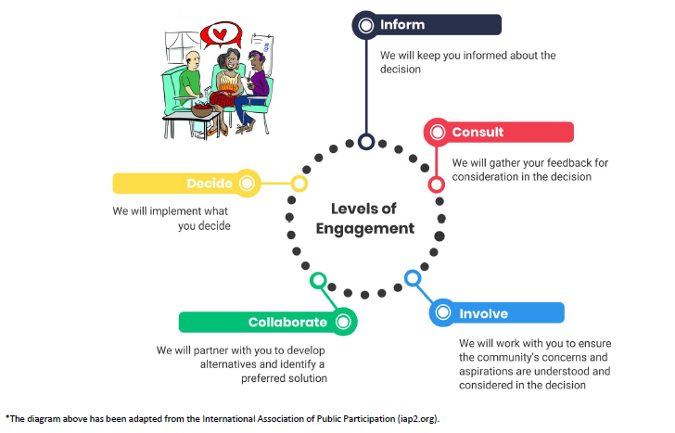
- There are different levels of participation on the International Association of Public Participation (IAP2) spectrum. Community Advisory Group members will participate at various levels for different agenda items. Generally, on the consult to involve level. On some matters, probably at the collaborate level.
Discussion: Once provincial accessibility legislation is in effect, the scope may be more empowering.
Kiran: We will adapt to whatever comes from the province. Perhaps the level of engagement may change, and that is great. There will be collaboration on the Request for Proposal process, and the job description may be more at the “involve” level on the IAP2 spectrum. Even in this first meeting, we will be engaging in a couple of different ways.
Question: What is the ultimate end goal for the Community Advisory Group’s work?
Kiran: It is improving services for everyone, in the North, on the Island. Any potential change will depend on the Request for Proposal.
Angela: The ultimate goal is to improve the service for the Deaf community. That is our mandate. The Community Advisory Group is the direct result of the initial consultation. At the moment, we are looking for two specific outputs: 1) the creation of the coordinator position and 2) the Request for Proposal for the service provider which is coming to an end in May. We want your input in that process. It does not mean that this is the only role for the Community Advisory Group, but if we address those two, we were making progress.
Action Item: The Community Advisory Group would benefit from a 30-min overview about Medical Interpreting Services, Provincial Language Services, etc. This can be planned for the second meeting and presented to the Communinty Advisory Group members - so that everyone has the same understanding of the systems currently in place.
- Collaborate to develop Operating Values for the advisory group
Facilitator: We want to be respectful of each others’ time and needs. Suggestions for operating values:
- Respect is our guiding light
- We will take a community-wide view for our recommendations
Any other suggestions:
- To think about everyone - birth to death, and not prioritizing one age group. Everyone is facing barriers. A value is we are humans, and if there is a problem with health, we need to listen to it. Deaf people have not been listened to, so we need to start there.
- Privacy and confidentiality of information in a health setting.
- We need to feel safe here, and that what we have heard and learned will be kept confidential. The Community Advisory Group is doing this work for the benefit of the community, but if individual members face issues due to our work on the Community Advisory Group, we would like to receive the support from Provincial Language Services representatives in addressing those issues.
- The work of the Community Advisory Group needs to be as transparent as possible with the community as the Community Advisory Group has been created to serve the community.
- Accessibility and accommodating language requirements and needs. I think that there are many individuals for whom communicating in English is challenging, whether that means sending in videos/video chats to send in concerns, particularly around discussion about accessibility legislation. We need to follow language requirements. It is really challenging to translate needs into English. Easy, accessible communication that is equitable and clear.
- Acknowledgement that relying on technology is not great for the Deaf-Blind community, especially people who are fully Deaf-Blind.
- Make all materials Deaf-Blind friendly – all fonts should be 18pt Arial.
- Send agenda and all other materials in a Word format in advance so that Community Advisory Group members have time to review them (many programs for the Deaf community work better with Word).

- Review and receive input on Draft Terms of Reference (ToR)
Facilitator: Community Advisory Group members can take some time to think about the draft ToR and discuss it at the next meeting. Currently, the Community Advisory Group has only 7 representatives and there is a spot for an Indigenous person.
Discussion:
- A member knows a person who would be good fit for this spot.
- There is also need for a person of colour (a racialized person) and a member of the LGBTQ community. That makes the group larger, but it is really important. I can see people and empathize with them, but I do not know their lived experience.
- This is an issue also at the national level – minority voices are not being represented, and it would be important to give them a spot on the Community Advisory Group.
- Are those spots available for the missing voices? Can Community Advisory Group members recruit representation from those communities? Yes, those voices should be represented.
Facilitator:
- Provincial Language Services is looking to you for your advice on how to reach these communities.
- Currently, draft ToR proposes a 2-year term for the Community Advisory Group with the possibility of renewal.
Discussion:
- Community Advisory Group members need to see how heavy the workload is and then make that decision.
- A longer term would make sense. Two years is not enough.
- When we get to the end of the 2 years, will the committee be disbanded? Sometimes 2 years is not enough especially when it is a new advisory group. We will need two years at least to make some change.
- Kiran: The advisory group is long-term, but after two years, there may be people who would want to stay and some who would want to leave. It is an opportunity to have some new people, but still keep the foundation of current members. The hope is that after the first year, Community Advisory Group would go to quarterly meetings. These next six months, there will be a lot asked of Community Advisory Group members.
- There is a lot of responsibility to have only one person representing the Deaf-Blind. Maybe we could have a bit more representation.
Facilitator: Our experience is that when the numbers get large, it gets harder to move things along. The two-year term is proposed so that new people have an opportunity to apply for the Community Advisory Group.
Kiran: It is really important that we are working like a working group because we need to get things done. I understand your roles can seem onerous. I think we need to get away from thinking of “representation.” Members are just sharing their experience.
Action Item: The Draft ToR will be shared with everyone and can be further discussed in the next meeting.
- Discuss and identify any stakeholder groups that are missing

Discussion:
- One concern is that there are no people of colour (POC or racialized persons) and LGBTQ people; you did mention Indigenous seat, but I think, there is more to consider.
- One person representing the entire Vancouver Island. Could there be a Northern and Southern Island representative? A lot of these representatives are from the Vancouver area and I am wondering if we can expand.
- Kiran: “Representing” is not the correct term. Representation sounds big. We want to make sure perspectives are brought to the table. The Selection Criteria asked for different perspectives and only few numbers with different perspectives applied.
- Angela: Your input is valuable, so please let us know how to get those voices on the Community Advisory Group.
Facilitator: So, missing voices are - Indigenous, youth, people of colour, LGBTQ. What about interpreters? Should they be included for the discussion on appropriate bookings, etc.? Should they join as guests?
Discussion:
- Strong support for involving a neutral interpreter in the discussion about bookings.
- Are Community Advisory Group members signing a non-disclosure agreement? This would ensure that people’s feedback is kept confidential.
Kiran: Part of Terms of reference (on page 3) is a bullet about confidentiality. It is quite general and then Community Advisory Group members will also be asked to take two short courses on privacy and confidentiality.
- Signing an agreement would have more weight.
Action Item: Non-disclosure agreements will be shared and signed – to ensure that everyone feels safe.
- Discuss the Request for Proposal process and confirm Request for Proposal components

Kiran: Explanation of the Request for Proposal process.
Discussion of Request for Proposal components.

- To review, review input and finalize the job description for the Coordinator

Angela: Explanation of the process of assessing and posting a Job Description.
Discussion about the components of the Job Description – responsibilities and qualifications.
Action Item: Community Advisory Group members to review the suggested components of the Job description and provide comments by Monday.
- Member Preferences for Communicating
Facilitator: Meeting notes + presentations posted on Provincial Language Services web page; any correspondence for the group to go through Provincial Language Services project email (pmslis@phsa.ca) and a summary brought forward by staff for discussion at each meeting. There is a formal process to consider emails in every meeting. There is no need to use private emails for communication with community members.
Angela: A community advisory group is a similar concept to a board where community can reach out to members. A generic email is essential so we can concentrate all that feedback and then share communication with Community Advisory Group members and discuss it.
Discussion about internal communication: everyone agrees with sharing each other’s emails; but this needs to be checked with the members who are not in attendance.
Discussion:
- Email is fine, but not too much email, and not too wordy communication.
- It would be good to have a designated website that is fully accessible to all Community Advisory Group members (so the members could vlog to address concerns, or people could post videos to Community Advisory Group (CAG) members and interact with CAG members) - a full website that is accessible for English and American Sign Language. Whenever Community Advisory Group is sharing updates, members could post vlogs and also receive confidential submissions.
Angela: That is a great idea, but it comes down to resourcing and funding. Making that website and maintaining it to be transparent, we might not be able to meet that expectation. But maybe we need to explore other options.
- A website would help with the confusion in the community -many people are confused about what is really going on. A one place for communication would reduce the amount of misinformation.
- When accessibility legislation is passed in the province that will give us power to ask for more funding. We may not have the funding right now but might be able to ask for the resources that are needed, like for the website.
Angela: I agree, we are very supportive, but I just do not want to create expectations. If there is an opportunity in the future, it will be explored.
Kiran: The current website is the standard Provincial Health Services Authority site. Kiran is working with my web team to create a place that would be more accessible within Provincial Health Services Authority current resources. The team is trying to do more vlogs but it is not a user-friendly process to get there. Kiran will be meeting with the team soon and try to work it out.
Facilitator: Would a Facebook group be appropriate?
Discussion:
- That would be amazing.
- Preference for it not to be a public page so that public cannot comment.
- It can be a private Facebook page/group.
- Confidentiality/privacy gets broken/compromised all the time on Facebook.
- Moderating a Facebook group is too much work. We would want to know that our responsibility is to share information. We need to figure out a way to communicate with the community and also protect ourselves.
Angela: Final note – as a new group, it would be good to think about your own ways of reaching out to the community. If it is a Facebook group where you could control the messaging, maybe that could be an option. But reaching out to the community would be important, in a way where you can control the messaging. If you need tools to work with the community, it could be done in parallel to that.
Facilitator: This can be further discussed at the next meeting.
- Evaluation and Next Steps
Kiran: Will commit to getting information earlier. Need to look at dates for next meeting. Will figure out a better remote technology like Telehealth. The next meeting date will be before mid-December.
Discussion:
- Zoom is good.
- Is there a way to make it more accessible for everyone and the interpreters? Dedicated screen for the interpreters would be great.
- Or all the Community Advisory Group members could attend with computers in front of them.

In all of our documents, we will be capitalizing “Deaf” as based on the Canadian Association of the Deaf Terminology, “Deaf (with capital D)” is defined as “a sociological term referring to those individuals who are medically deaf or hard of hearing who identify with and participate in the culture, society, and language of Deaf people, which is based on Sign language. Their preferred mode of communication is Sign.” The definition of “deaf” is “a medical/audiological term referring to those people who have little or no functional hearing. May also be used as a collective noun (“the deaf”) to refer to people who are medically deaf but who do not necessarily identify with the Deaf community.

