Skype for Business – Quick Start Guides

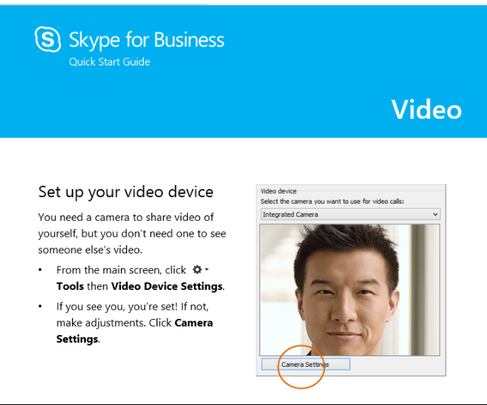
Click to Download (English)
- Audio setup and making Calls
- Contacts, presence, and IM
- Meetings
- Sharing and collaboration
- Video
Get localized versions:
Language | Link to .ZIP Download
Arabic | http://download.microsoft.com/download/3/0/C/30C6ED84-B2CD-49E3-8116-9A1FCD86FDC5/SkypeforBusinessQuickStartGuides-ar-SA.zip
Brazilian Portuguese | http://download.microsoft.com/download/C/E/D/CED814C1-FC78-4C32-816C-9F1CD5495805/SkypeforBusinessQuickStartGuides_pt-BR.zip
Bulgarian | http://download.microsoft.com/download/2/C/D/2CDCA0DA-CB09-400E-AA91-DBA5BF84BFE7/SkypeforBusinessQuickStartGuides-bg-BG.zip
Chinese (Simplified) | http://download.microsoft.com/download/9/C/D/9CDD3187-41FC-423F-A955-06DF87CD0779/SkypeforBusinessQuickStartGuides-zh-CN.zip
Chinese (Traditional) | http://download.microsoft.com/download/C/4/8/C481E570-51D9-4A2E-9371-F8BF65E10309/SkypeforBusinessQuickStartGuides-zh-TW.zip
Czech | http://download.microsoft.com/download/6/B/9/6B93B61A-5DA5-4CCB-8DDF-03DC96788A94/SkypeforBusinessQuickStartGuides-cs-cz.zip
Danish | http://download.microsoft.com/download/D/0/9/D09AA400-B486-4980-993E-8AA225E20174/SkypeforBusinessQuickStartGuides-da-DK.zip
Dutch | http://download.microsoft.com/download/4/D/A/4DAC2CB0-6BBB-49BD-A01C-67E1383AF441/SkypeforBusinessQuickStartGuides-nl-NL.zip
Finnish | http://download.microsoft.com/download/D/F/E/DFEA50B2-4F3C-4F06-85D3-1B984C65F489/SkypeforBusinessQuickStartGuides-fi-FI.zip
French | http://download.microsoft.com/download/2/2/3/2235BA7D-BDF0-48D0-B305-150CA871797F/SkypeforBusinessQuickStartGuides_fr-FR.zip
German | http://download.microsoft.com/download/8/B/9/8B9625F6-9D8D-4DE4-823F-4F1F1DE795FE/SkypeforBusinessQuickStartGuides_de-DE.zip
Greek | http://download.microsoft.com/download/0/D/4/0D4D11A9-6249-40EF-8815-D7F6FE908E88/SkypeforBusinessQuickStartGuides-el-GR.zip
Hebrew | http://download.microsoft.com/download/2/D/F/2DFA8234-D333-4DD9-B2BB-EE59CE53625D/SkypeforBusinessQuickStartGuides-he-IL.zip
Hindi | http://download.microsoft.com/download/4/1/9/41984864-EE41-4C1D-8312-B2E9A56086A7/SkypeforBusinessQuickStartGuides-hi-IN.zip
Hungarian | http://download.microsoft.com/download/D/7/7/D77618B2-80F1-4C4B-ADDC-31C059B32E87/SkypeforBusinessQuickStartGuides-hu-hu.zip
Indonesian | http://download.microsoft.com/download/2/6/3/26358595-58B1-4E64-8128-684A866148A1/SkypeforBusinessQuickStartGuides-id-ID.zip
Italian | http://download.microsoft.com/download/F/2/9/F2984011-C03B-4148-AD8C-33EAF770E3DA/SkypeforBusinessQuickStartGuides-it-IT.zip
Japanese | http://download.microsoft.com/download/4/B/9/4B9113FB-2F13-42E2-8144-D575732C1A8D/SkypeforBusinessQuickStartGuides_ja-JP.zip
Korean | http://download.microsoft.com/download/A/F/D/AFD7E7C8-42A7-4062-92D7-7D185C709942/SkypeforBusinessQuickStartGuides-ko-KR.zip
Malaysian | http://download.microsoft.com/download/3/D/7/3D728BB9-1E80-472A-8D4A-0F16B9891236/SkypeforBusinessQuickStartGuides-ms-MY.zip
Norwegian | http://download.microsoft.com/download/7/5/F/75F4D0B3-D088-4317-8C34-23B7EB9D8C1A/SkypeforBusinessQuickStartGuides-nb-NO.zip
Polish | http://download.microsoft.com/download/9/6/F/96F4024D-F8EA-45CC-85B4-B9E6E909AF65/SkypeforBusinessQuickStartGuides-pl-pl.zip
Portuguese | http://download.microsoft.com/download/0/7/6/07620121-DAEA-4F8A-89D6-50CDF89243C1/SkypeforBusinessQuickStartGuides-pt-PT.zip
Romanian | http://download.microsoft.com/download/2/A/4/2A432D8A-5012-4DE8-ADC0-CE999F0D9297/SkypeforBusinessQuickStartGuides-ro_RO.zip
Russian | http://download.microsoft.com/download/2/2/3/2235BA7D-BDF0-48D0-B305-150CA871797F/SkypeforBusinessQuickStartGuides_fr-FR.zip
Serbian (Latin) | http://download.microsoft.com/download/F/2/7/F27A6AE4-F55F-416A-9CA8-0376C996E717/SkypeforBusinessQuickStartGuides-sr-Latn-RS.zip
Slovak | http://download.microsoft.com/download/C/E/A/CEA8543D-7997-4035-B806-D7537D0D8C3F/SkypeforBusinessQuickStartGuides-sk-sk.zip
Spanish | http://download.microsoft.com/download/4/5/5/45527B44-FF1E-4D39-A6D7-CB9FDE726977/SkypeforBusinessQuickStartGuides_es-ES.zip
Swedish | http://download.microsoft.com/download/E/D/9/ED9E5A48-55F9-49D3-9A49-F202E1F6BAA4/SkypeforBusinessQuickStartGuides-sv-SE.zip
Thai | http://download.microsoft.com/download/5/7/A/57A78027-8D03-48A8-9FF5-373CD15379C4/SkypeforBusinessQuickStartGuides-th-TH.zip
Vietnamese | http://download.microsoft.com/download/C/A/9/CA96634F-1054-462D-8425-7C64DFD49A69/SkypeforBusinessQuickStartGuides-vi-VN.zip

